Feladat
Hajózás: tenger, kikötő, hajó, teherhajó, utasszállító hajó, áru, olaj, konténer.
Létrehoz egy tengert, a partján több kikötőt, és a hajózási vállalat bevételét méri egy szimulációban.
A szállított áru lehet olaj vagy konténerekben elhelyezett áru.
A kikötők távolsága egymástól eltérő.

Bemenő adatok
Pszeudovéletlenszámokkal dolgoztam.

Javadoc
Minden funkcióhoz készítettem rövid leírást.
Példa:
/**
* Carefully removes as much weight as possible, but doesn't underflow.
*
* @param weight the amount to try and subtract.
* @return how much we actually managed to subtract
*/
public double rmWeight(double weight) {
if (this.weight >= weight) {//We can subtract...
this.weight -= weight;//So we subtract.
return weight;
} else {
//We need to return how much we actually managed to subtract.
double tmp = SeaTrading.round(this.weight);
this.weight = 0;
return tmp;
}
}
Használatban:
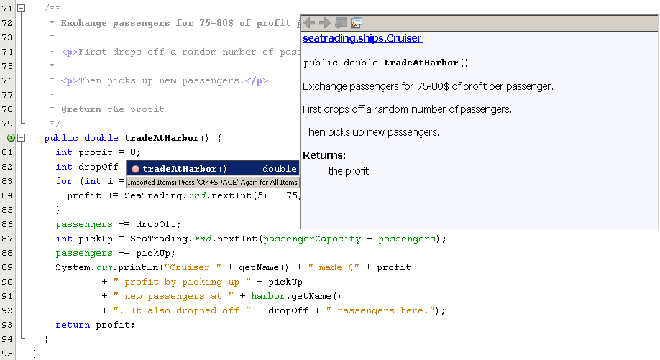

UML (main)
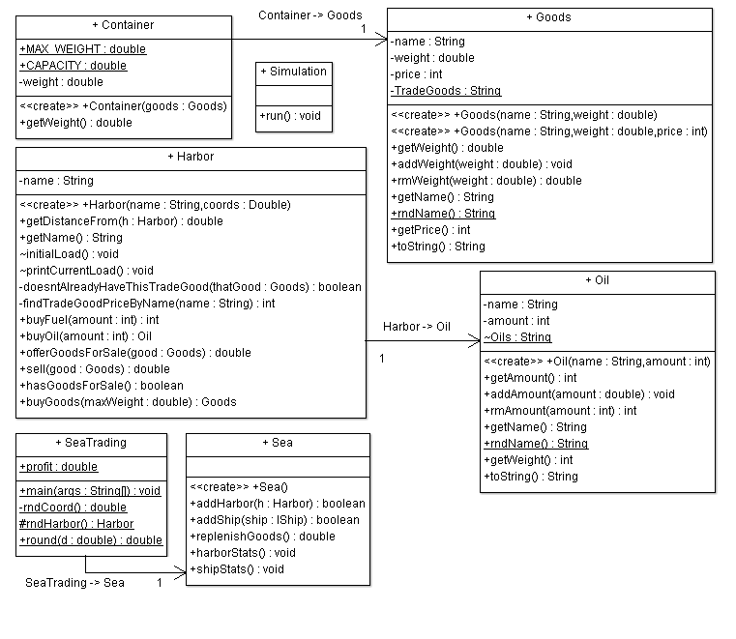

UML (ships)
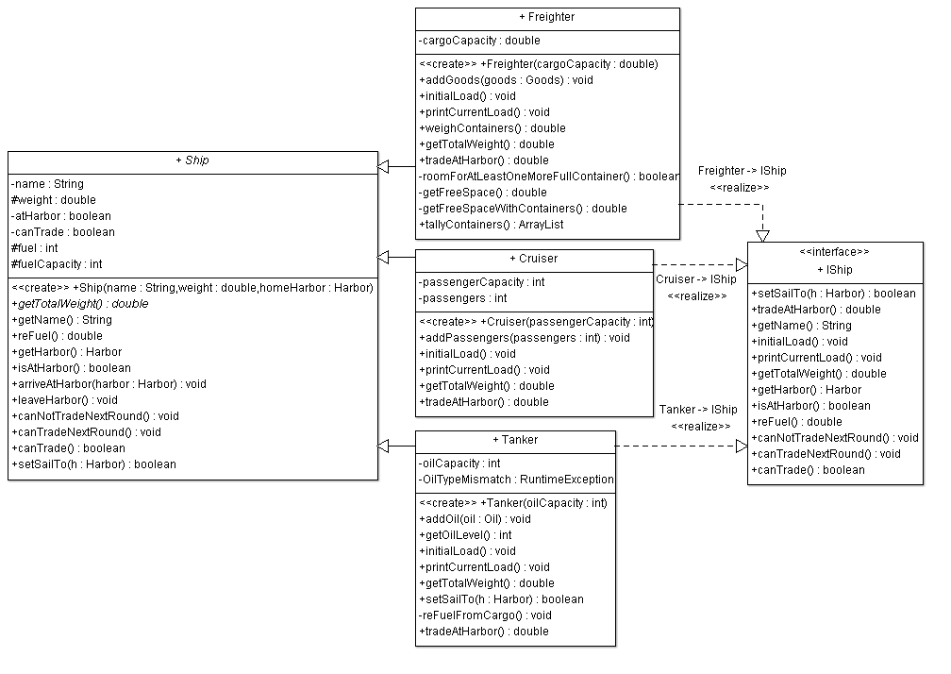

UML (sea)
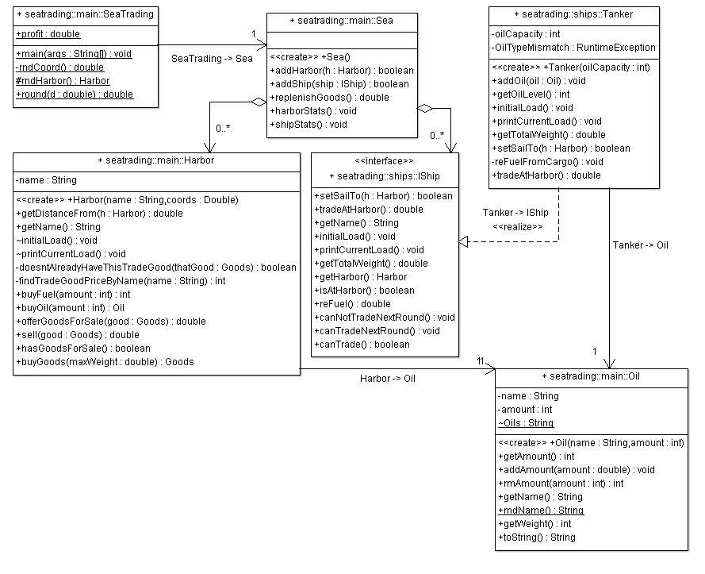

Példa kimenet
Creating famous actual harbors (but at random locations and on the same sea):
Creating a harbor called "Sydney Port" at (1519.6, 8927.0).
...
Creating a harbor called "Shanghai International" at (1195.4, 364.7).

Creating famous cruisers (with mostly actual stats from Wikipedia and misc. research):
Creating a cruiser called "Titanic". It weighs 52.31 tons and has 2435 passenger capacity. It currently resides in Shanghai International.
...
Creating a cruiser called "Oasis of the Seas". It weighs 225.282 tons and has 6296 passenger capacity. It currently resides in Port Falmouth.

Creating a well-known and some of the largest freighters (with actual stats again):
Creating a freighter called "Edmund Fitzgerald". It weighs 13632.1 tons and has 30690.3 cargo capacity. It currently resides in Sydney Port.
...
Creating a freighter called "Fabiola". It weighs 140259.0 tons and has 301488.2 cargo capacity. It currently resides in Mumbai Bay.

Creating two of the largest oil tankers:
Creating a tanker called "AbQaiq". It weighs 100000 tons and has 550000 m³ oil capacity. It currently resides in Port Falmouth.
Creating a tanker called "Hellespont Alhambra". It weighs 90000 tons and has 441893 m³ oil capacity. It currently resides in Sydney Port.

Starting every harbor with a random stock of goods:
Sydney Port has 181452 m³ Heating oil, 32906.1 tons of Rice, 64329.4 tons of Ferrous scrap, 68203.0 tons of Pork, 33760.5 tons of Plastic, 5590.7 tons of Silver, 22208.6 tons of Orange juice, 96897.5 tons of Copper, 16988.0 tons of Oats.
...
Shanghai International has 437482 m³ Crude oil, 79278.3 tons of Corn.

Starting every freighter with a couple random goods (cruisers get passengers and tankers get oil, of course):
Cruiser Titanic has 70/2435 passengers.
...
Cruiser Oasis of the Seas has 1279/6296 passengers.
Freighter Edmund Fitzgerald has; 1218.7 tons of Eggs; 260.4 tons of Gold; 760.4 tons of Aluminum; 1436.9 tons of Wheat; 245.8 tons of Oats; 780.1 tons of Nickel; 391.2 tons of Rice. (164 containers, 32785.6/30690.3 tons)
...
Freighter CSCL Star has; 4955.9 tons of Eggs; 4781.8 tons of Orange juice; 6733.6 tons of Cocoa; 3677.4 tons of Soybeans; 6971.2 tons of Corn. (849 containers, 330624.6/155470.7 tons)
Tanker AbQaiq has 56759/550000 m³ Heating oil.
Tanker Hellespont Alhambra has 60877/441893 m³ Gasoline.

Giving the company some starting cash: $68906.8

Begin simulation!
Cruiser Titanic made $1837 profit by picking up 1540 new passengers at Shanghai International. It also dropped off 24 passengers here.
Titanic sets off on a journey to Sydney Port...
...
Freighter Edmund Fitzgerald made $987.5 profit by dropping off 4879.7 tons of trade goods at Sydney Port. It also picked up 28639.1 tons of new goods.
Edmund Fitzgerald is being repaired at Sydney Port
Edmund Fitzgerald sets off on a journey to Victoria Seaport...
Freighter Fabiola made $7190.5 profit by dropping off 27627.9 tons of trade goods at Mumbai Bay. It also picked up 63339.7 tons of new goods.
Fabiola sets off on a journey to Sydney Port...
Replenishing goods at harbors: 4416627.0 tons of goods have been added.
Profit update: $211905.8
Freighter CSCL Star made $4296.0 profit by dropping off 27119.9 tons of trade goods at Sydney Port. It also picked up 146292.6 tons of new goods.
CSCL Star sets off on a journey to Shanghai International...
Tanker AbQaiq made $-19369 profit by dropping off 56759 m³ Heating oil at Port Falmouth and purchasing 308009 m³ Gasoline.
AbQaiq sets off on a journey to Shanghai International...
Tanker Hellespont Alhambra made $-16022 profit by dropping off 60877 m³ Gasoline at Sydney Port and purchasing 274437 m³ Heating oil.
Hellespont Alhambra sets off on a journey to Port Falmouth...
Replenishing goods at harbors: 3681694.5 tons of goods have been added.

Random ship stats:
Cruiser Titanic has 1586/2435 passengers.
Cruiser Queen Elizabeth has 1439/2283 passengers.
Cruiser Queen Mary II has 1417/2620 passengers.
Cruiser Freedom of the Seas has 1963/3634 passengers.
Cruiser Oasis of the Seas has 4874/6296 passengers.
Freighter Edmund Fitzgerald has; 85.8 tons of Oats; 28528.6 tons of Pork; 238.5 tons of Rice. (903 containers, 58007.0/30690.3 tons)
Freighter Fabiola has; 50013.7 tons of Silver; 17587.9 tons of Beef. (2114 containers, 352260.6/301488.2 tons)
Freighter TI Asia has; 23568.7 tons of Aluminum. (737 containers, 493084.7/441893.3 tons)
Freighter Colombo Express has; 79278.3 tons of Corn. (2478 containers, 271816.8/104400.2 tons)
Freighter Ebba Maersk has; 55796.8 tons of Corn. (1744 containers, 362720.6/156907.6 tons)
Freighter APL Southampton has; 123125.0 tons of Plastic. (3849 containers, 388764.9/131358.1 tons)
Freighter CSCL Star has; 0.4 tons of Orange juice; 246.3 tons of Copper; 63221.2 tons of Oats; 82824.8 tons of Rice. (4574 containers, 457168.4/155470.7 tons)
Tanker AbQaiq has 308009/550000 m³ Gasoline.
Tanker Hellespont Alhambra has 274437/441893 m³ Heating oil.
Profit update: $-8782458.2
Sailing from Mumbai Bay to Port Falmouth took Queen Mary II 13 hours.
Cruiser Queen Mary II made $44313 profit by picking up 900 new passengers at Port Falmouth. It also dropped off 576 passengers here.
Sailing from Shanghai International to Sydney Port took Titanic 13 hours.
Queen Mary II sets off on a journey to Mumbai Bay...
Cruiser Titanic made $66849 profit by picking up 1087 new passengers at Sydney Port. It also dropped off 868 passengers here.
...
Sailing from Port Falmouth to Victoria Seaport took APL Southampton 17 hours.
Freighter APL Southampton made $5751.5 profit by dropping off 123125.0 tons of trade goods at Victoria Seaport. It also picked up 123600.0 tons of new goods.
APL Southampton sets off on a journey to Mumbai Bay...

Random harbor stats!
Sydney Port has 1747206 m³ Heating oil, 64854.8 tons of Rice, 189457.2 tons of Ferrous scrap, 192696.7 tons of Pork, 260327.2 tons of Plastic, 168367.6 tons of Silver, 151316.8 tons of Orange juice, 243600.1 tons of Copper, 174648.5 tons of Oats.
Victoria Seaport has 2925266 m³ Crude oil, 108490.5 tons of Beef, 202514.1 tons of Soybeans, 25258.2 tons of Oats.
Mumbai Bay has 2187535 m³ Gasoline, 184441.0 tons of Silver, 108620.8 tons of Beef, 281912.5 tons of Platinum, 146042.6 tons of Ferrous scrap.
Port Falmouth has 1753703 m³ Gasoline, 73801.7 tons of Aluminum, 176940.0 tons of Plastic, 254813.9 tons of Ferrous scrap.
Shanghai International has 2002520 m³ Crude oil, 166106.1 tons of Corn.
Profit update: $-8590275.7
Sailing from Victoria Seaport to Port Falmouth took Colombo Express 6 hours.
Freighter Colombo Express made $16252.0 profit by dropping off 98129.6 tons of trade goods at Port Falmouth. It also picked up 98228.1 tons of new goods.
Colombo Express sets off on a journey to Sydney Port...
Replenishing goods at harbors: 3243689.8 tons of goods have been added.
Profit update: $-8574023.7
...
Random harbor stats!
Sydney Port has 2573405 m³ Heating oil, 113677.7 tons of Rice, 344854.2 tons of Ferrous scrap, 217387.9 tons of Pork, 346766.3 tons of Plastic, 238699.0 tons of Silver, 253804.4 tons of Orange juice, 343099.0 tons of Copper, 305932.2 tons of Oats.
Victoria Seaport has 3976322 m³ Crude oil, 240602.2 tons of Beef, 299988.2 tons of Soybeans, 174113.5 tons of Oats.
Mumbai Bay has 2626212 m³ Gasoline, 254971.4 tons of Silver, 178805.6 tons of Beef, 395438.6 tons of Platinum, 201956.9 tons of Ferrous scrap.
Port Falmouth has 2393472 m³ Gasoline, 69934.4 tons of Aluminum, 278877.3 tons of Plastic, 268822.5 tons of Ferrous scrap.
Shanghai International has 3153596 m³ Crude oil, 195058.0 tons of Corn.
Profit update: $-8430672.7
Sailing from Victoria Seaport to Mumbai Bay took Edmund Fitzgerald 40 hours.
Freighter Edmund Fitzgerald made $2656.5 profit by dropping off 17038.6 tons of trade goods at Mumbai Bay. It also picked up 16972.5 tons of new goods.
Edmund Fitzgerald sets off on a journey to Port Falmouth...
Sailing from Port Falmouth to Shanghai International took TI Asia 70 hours.
Freighter TI Asia made $7726.5 profit by dropping off 23568.7 tons of trade goods at Shanghai International. It also picked up 195058.0 tons of new goods.
TI Asia sets off on a journey to Sydney Port...
Replenishing goods at harbors: 3482240.7 tons of goods have been added.
Profit update: $-8420289.7
Sailing from Sydney Port to Port Falmouth took Hellespont Alhambra 63 hours.
Tanker Hellespont Alhambra made $25902 profit by dropping off 274437 m³ Heating oil at Port Falmouth and purchasing 82705 m³ Gasoline.
Hellespont Alhambra sets off on a journey to Sydney Port...
Sailing from Mumbai Bay to Port Falmouth took Edmund Fitzgerald 2 hours.
Freighter Edmund Fitzgerald made $6879.0 profit by dropping off 21554.8 tons of trade goods at Port Falmouth. It also picked up 21538.4 tons of new goods.
Edmund Fitzgerald sets off on a journey to Shanghai International...
Sailing from Victoria Seaport to Shanghai International took Titanic 10 hours.
Cruiser Titanic made $7767 profit by picking up 58 new passengers at Shanghai International. It also dropped off 101 passengers here.
Sadly, Titanic can't get to Sydney Port.
Titanic sets off on a journey to Victoria Seaport...
Profit update: $-8379741.7
Sailing from Port Falmouth to Shanghai International took Ebba Maersk 22 hours.
Freighter Ebba Maersk made $31185.0 profit by dropping off 95089.2 tons of trade goods at Shanghai International. It also picked up 33026.2 tons of new goods.
Ebba Maersk sets off on a journey to Mumbai Bay...
Sailing from Mumbai Bay to Sydney Port took Queen Elizabeth 50 hours.
Cruiser Queen Elizabeth made $16494 profit by picking up 251 new passengers at Sydney Port. It also dropped off 214 passengers here.
Queen Elizabeth sets off on a journey to Victoria Seaport...
Sailing from Sydney Port to Shanghai International took CSCL Star 79 hours.
Replenishing goods at harbors: 2706250.8 tons of goods have been added.
Profit update: $-8332062.7
Freighter CSCL Star made $-7248700.5 profit by dropping off 146292.7 tons of trade goods at Shanghai International. It also picked up 22084.5 tons of new goods.
CSCL Star sets off on a journey to Victoria Seaport...
Sailing from Port Falmouth to Sydney Port took Colombo Express 51 hours.
Freighter Colombo Express made $14767.0 profit by dropping off 59105.3 tons of trade goods at Sydney Port. It also picked up 59104.1 tons of new goods.
Colombo Express sets off on a journey to Victoria Seaport...
Sailing from Shanghai International to Victoria Seaport took Titanic 7 hours.
Cruiser Titanic made $10159 profit by picking up 240 new passengers at Victoria Seaport. It also dropped off 132 passengers here.
Titanic sets off on a journey to Shanghai International...
Sailing from Port Falmouth to Shanghai International took Edmund Fitzgerald 12 hours.
Replenishing goods at harbors: 2940644.9 tons of goods have been added.
Freighter Edmund Fitzgerald made $-2880714.0 profit by dropping off 28770.4 tons of trade goods at Shanghai International. It also picked up 28852.9 tons of new goods.
Profit update: $-1.55558372E7
Edmund Fitzgerald sets off on a journey to Port Falmouth...
Sailing from Port Falmouth to Shanghai International took AbQaiq 91 hours.
Tanker AbQaiq made $-7614 profit by dropping off 308009 m³ Gasoline at Shanghai International and purchasing 524417 m³ Crude oil.
AbQaiq sets off on a journey to Port Falmouth...
Sailing from Victoria Seaport to Shanghai International took Titanic 1 hours.
Cruiser Titanic made $119639 profit by picking up 1529 new passengers at Shanghai International. It also dropped off 1553 passengers here.
Titanic sets off on a journey to Victoria Seaport...
BUILD STOPPED (total time: 2 seconds)

